Dear Community Partner,
On behalf of President Gwenette Westbrooks and Justin Brown Rouse, Convention Chair, we are pleased to invite you to partner with the NAACP Georgia State Conference as a sponsor of the 84th Annual NAACP Georgia State Conference Convention, to be held October 1–3, 2026, at the Macon Marriott City Center in Macon, Georgia.
Under the theme, "We the People: Engage, Empower, Elevate," the 84th Annual NAACP Georgia State Conference Convention will bring together civil rights leaders, elected officials, business professionals, entrepreneurs, educators, faith leaders, students, and community advocates from across Georgia to engage in meaningful dialogue, leadership development, economic empowerment initiatives, and strategic action that advances equity, opportunity, and justice for all.
As one of Georgia's premier gatherings focused on civic engagement and community impact, the convention serves as a catalyst for collaboration, innovation, and leadership. Through dynamic workshops, plenary sessions, youth and college programming, community service initiatives, networking opportunities, and the prestigious Freedom Fund Banquet, attendees will be inspired to strengthen communities and build a more equitable future for all Georgians.
We respectfully invite your organization to become a sponsor of this impactful statewide event. Your investment will directly support convention programming, leadership development, youth engagement, civic education, and community outreach efforts while demonstrating your organization's commitment to advancing equality, economic opportunity, and social justice throughout Georgia.
As a valued convention sponsor, your organization will receive recognition and benefits that may include:
- Recognition in the Official Convention Program and Freedom Fund Banquet Journal
- Recognition on the NAACP Georgia State Conference website and social media platforms
- Logo placement on selects convention marketing and promotional materials
- Complimentary or discounted exhibitor/vendor opportunities (based on sponsorship level)

- Invitations and reserved seating at select convention events, including the Freedom Fund Banquet
- Recognition during convention sessions and special events
- Opportunities to engage with convention attendees, community leaders, and stakeholders from across Georgia

In addition, your partnership will demonstrate your organization's commitment to civic engagement, community investment, leadership development, and advancing opportunities that strengthen families and communities throughout our state.
To ensure your organization receives full recognition in convention marketing materials, printed publications, signage, and the Official Convention Program, we kindly request that all sponsorship commitments be received no later than Tuesday, September 1, 2026. Early confirmation allows us to maximize your organization's visibility throughout the convention experience.
We hope you will join us in supporting this historic statewide gathering and the continued work of the NAACP Georgia State Conference. Together, we can create lasting changes by empowering leaders, engaging communities, and elevating the voices of those we serve.
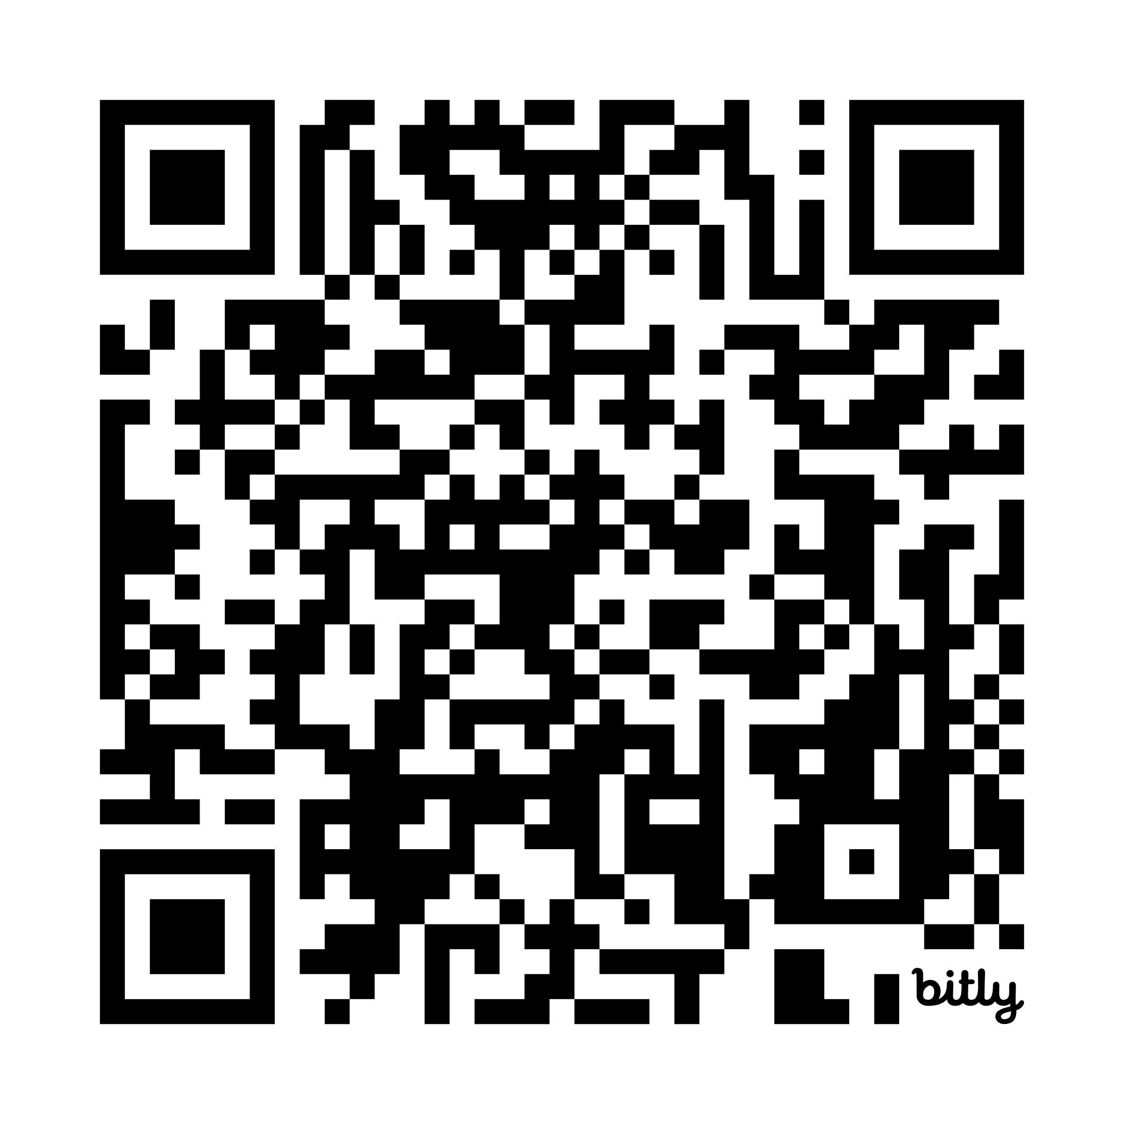
Please contact our Convention Chair to discuss partnership opportunities and answer any questions about sponsorships. To confirm your sponsorship, please go to our State Convention webpage for forms and payment instructions.
Justin Rouse
Convention Chair, NAACP Georgia State Conference
Webpage: https://www.georgianaacp.org/stateconvention
Email: naacpgastateconvention@gmail.com
Office: (404) 577-8977 | Mobile: (404) 235-9637
1691 Phoenix Boulevard, Suite 150 | Atlanta, Georgia 30349

Thank you for your consideration and your commitment to strengthening communities across Georgia. We look forward to partnering with you as we celebrate the 84th Annual NAACP Georgia State Conference Convention and continue advancing the mission of justice, equity, and opportunity for all.

In Solidarity,
Gwenette Westbrooks
President, NAACP Georgia State Conference

